SYSC 5104 Assignment 1
King’s Court Discrete Event Simulation

Part 1: Conceptual Model Description

Description of the Game King’s Court:
King’s Court (aka Four Square) is a popular children’s playground game. The game consists of four squares drawn on the ground, one for each player, and a ball. The squares are labeled 1, 2, 3 and King, as shown in the figure below.
1
K
3
2

Figure 1: King’s Court Layout
The ball is served by the King to anyone of the other three players. The player must let the ball bounce in their square before hitting the ball to one of the other three players. If the player misses the ball after it bounces in their square or a player hits the ball out or the player catches the ball, they are considered out. They must leave the court, allowing all players below them to move up one square and a player from the waiting queue to join the game in square 1.

Description of Simulation of King’s Court:
The model of the King’s Court Game will have four atomic models which represent the four players: Player1, Player2, Player3, and PlayerKing. The players will be modeled the same way, except for a slight change with PlayerKing, as they must start the game as the server.
In the beginning all players will be in the idle state until 4 players have joined the game. The number of players in the King’s Court Game will be tracked with a state variable called count. This state variable is controlled by the PlayerCount. When there are 4 players the play event will be sent causing Player1, 2 and 3 to move to the defending state and the PlayerKing will be in the attacking state, as the king starts with the ball. When the ball bounces in a player’s square the player will move into the attacking state. In the attacking state the player must decide at random which of the three players they will send the ball to. Once they have hit the ball they return to the defending state. There is also a chance the player who is attacking will miss the ball, catch the ball or not hit the ball into another player’s square. This is a miss event. When the error event occurs that player is out and a new player will join the game from the queue. The miss event is sent to each player to send them to the idle state and the PlayerCount to decrement the number of players and ask the queue for a new player. The queue contains new players who want to join the game. Each time a new player arrives they will be added to the waiting queue if all four squares on the court are filled.
On the following page Figure 2 is a diagram of the model described.

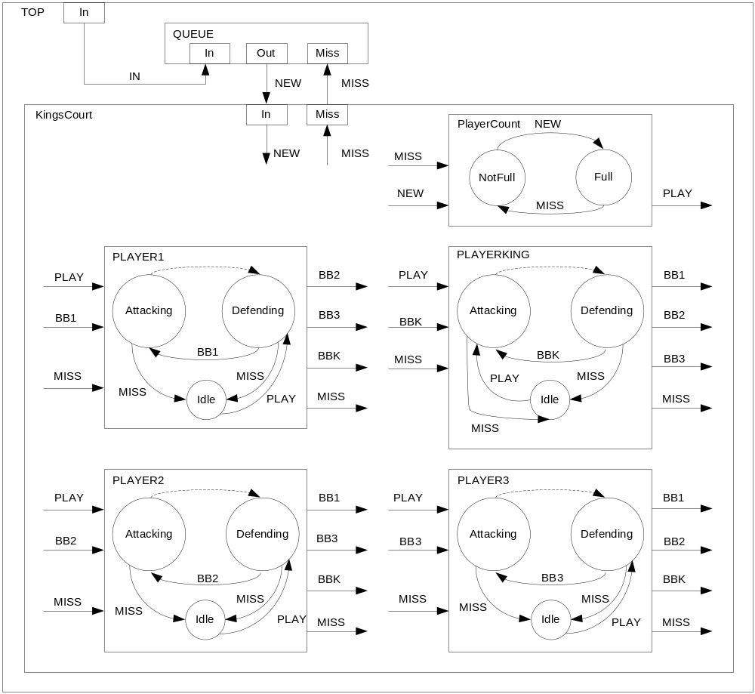
Figure 2: Diagram of Model Description

Part 2: Organization of Models, DEVS Formal Specification and Testing Strategy

The atomic models in the KingsCourt coupled model are the 4 players: Player1, Player2, Player3, PlayerKing, and PlayerCount. There is also another atomic model called Queue. KingsCourt and Queue are contained in the Top Model.
The following is the DEVS formal specification for each part of the model.

For diagram of KingsCourt see previous page.
-KingsCourt=<X, Y, D, {Player1, Player2, Player3, PlayerKing, PlayerCount},
EIC, EOC, IC, SELECT>
X={NEW}
Y={OUT}
EIC={(KingsCourt.NEW, PlayerCount.NEW)}

EOC={(Player1.MISS, KingsCourt.MISS), (Player2.MISS, KingsCourt.MISS), (Player3.MISS, KingsCourt.MISS), (PlayerKing.MISS, KingsCourt.MISS)}

IC={(Player1.BB2, Player2.BB2), (Player1.BB3, Player3.BB3), (Player1.BBK, PlayerKing.BBK), (Player2.BB1, Player1.BB1), (Player2.BB3, Player3.BB3), (Player2.BBK, PlayerKing.BBK), (Player3.BB1, Player1.BB1), (Player3.BB2, Player2.BB2), (Player3.BBK, PlayerKing.BBK), (PlayerKing.BB1, Player1.BB1), (PlayerKing.BB2, Player2.BB2), (PlayerKing.BB3, Player3.BB3), (Player1.MISS, Player1.MISS), (Player1.MISS, Player2.MISS), (Player1.MISS, Player3.MISS), (Player1.MISS, PlayerKing.MISS), (Player1.MISS, PlayerCount.MISS), (Player2.MISS, Player2.MISS), (Player2.MISS, Player1.MISS), (Player2.MISS, Player3.MISS), (Player2.MISS, PlayerKing.MISS), (Player2.MISS, PlayerCount.MISS), (Player3.MISS, Player3.MISS), (Player3.MISS, Player1.MISS), (Player3.MISS, Player2.MISS), (Player3.MISS, PlayerKing.MISS), (Player3.MISS, PlayerCount.MISS), (PlayerKing.MISS, PlayerKing.MISS), (PlayerKing.MISS, Player1.MISS), (PlayerKing.MISS, Player2.MISS), (PlayerKing.MISS, Player3.MISS), (PlayerKing.MISS, PlayerCount.MISS), (PlayerCount.PLAY, Player1.PLAY), (PlayerCount.PLAY, Player2.PLAY), (PlayerCount.PLAY, Player3.PLAY), (PlayerCount.PLAY, PlayerKing.PLAY)}

SELECT: ({Player1, Player2, Player3, PlayerKing, PlayerCount})=PlayerCount
({Player1, Player2, Player3, PlayerKing})=PlayerKing
({Player1, Player2, Player3})=Player3
({Player1, Player2})=Player2

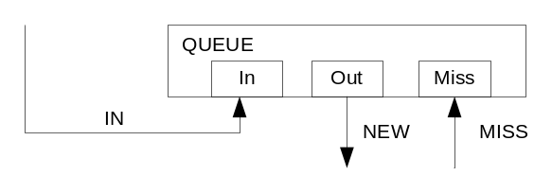
-Queue=< S, X, Y, δ_{int}, δ_{ext}, λ, ta>
S={queueState ε {active, passive}, queue.length in [0, N], count ε N, send ε N }
X={IN, MISS}
Y={NEW}
δ_{int}(s){passivate();}
δ_{ext}(in, n)=n+1 for all 0≤n≤N
δ_{ext}(miss, n)=n-1 for all 0<n≤N
δ_{ext}(S, e, X){
if(X.port == IN){
if(count<4){
// used in the beginning to send first 4 players directly into game
count++; queueState = active;
ta(queueState) = 0.1; send = true;
}
else{
add(x.value, s.queue);
send = false;
state = passive; ta(queueState) = infinity;
}
}
else if(X.port == MISS){
queueState = active; ta(state) = 0.1;
if(size==0){
count--; // next player who comes goes straight to game
send = false;
}
removeFirst(s.queue);
send = true;
}
}
λ(queueState){
if(send) output(time, NEW, 1);
}

TEST INPUT: The test case goes as follows. Add 5 players to the queue (4 should go straight to the game) and then sending a MISS event, asking the queue for a new player. Then ask for a new player from an empty queue. This should just cause it to wait until the new player shows up. Have the new player show up 10 seconds later.

00:00:00:05 IN 1
00:00:00:15 IN 2
00:00:00:25 IN 3
00:00:00:35 IN 4
00:00:00:45 IN 5
00:00:00:55 MISS 1
00:00:01:05 MISS 1
00:00:01:15 IN 6

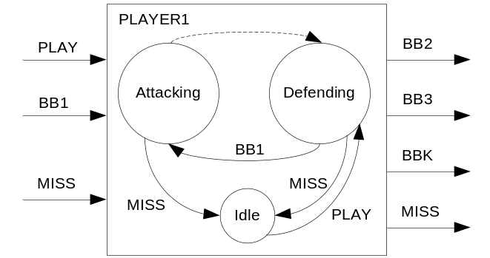
-Player1=<S, X, Y, δ_{int}, δ_{ext}, λ, ta>
S={playerState ε {Attacking, Defending, Idle}, sendBB2, sendBB3, sendBBK, sendMISS, random, thinking_time}
X={PLAY, BB1, MISS}
Y={BB2, BB3, BBK, MISS}
δ_{int}(Attacking)=Defending
δ_{int}(playerState){
//Internal transition occurs when user is done attacking.
if(playerState==Attacking) playerState=Defending;
passivate();
}
δ_{ext}(BB1, Defending)=Attacking
δ_{ext}(MISS, Attacking)=Idle
δ_{ext}(MISS, Defending)=Idle
δ_{ext}(PLAY, Idle)=Defending
δ_{ext}(S,e,X){
if(X.port==MISS){
// someone has missed the ball
playerState = Idle; ta(playerState) = infinity; //passivate
}
else if(X.port==PLAY){
// There are enough people to being playing
// Move to defending state and wait
playerState = Defending; ta(playerState) = infinity; //passivate
}
else if(X.port==BB1){
//Generate random number to see if ball is missed
playerState = Attacking; ta(playerState)=thinking_time;
random = generate random number
if(X.value < random){
sendMISS=true
playerState = Idle; ta(playerState) = infinity; //passivate
}
else{
// ball hit
//Generate random number to decide who to send ball to
random = generate random number
if(random<0.33){
sendBB2=true
}
else if(random<0.67){
sendBB3=true
}
else{
sendBBK=true
}
}
}
}
λ(Attacking)= sendBB2 || sendBB3 || sendBBK || sendMISS
λ(playerState){
if(sendBB2){
sendOutput(time, BB2, 1);
}
else if(sendBB3){
sendOutput(time, BB3, 1);
}
else if(sendBBK){
sendOutput(time, BBK, 1);
}
else{
sendOutput(time, MISS, 1);
}
}
ta(Attacking)=thinking_time
ta(Defending)=INFINITY
ta(Idle)=INFINITY

TEST INPUT: The test input for the four players in the game is basically the same. Only thing that changes is the name of the event being sent to notify the user the ball has bounced in their court. Basic test is to send the player the PLAY event. From there send the player the ball twice and then send the player the miss event.

00:00:00:01 PLAY 1
00:00:00:10 BB1 2
00:00:00:30 BB1 7
00:00:00:31 MISS 1

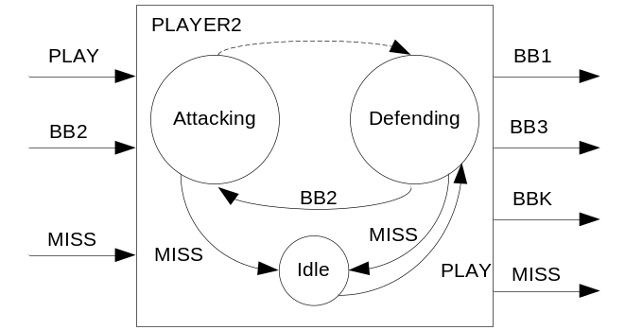
-Player2=<S, X, Y, δ_{int}, δ_{ext}, λ, ta>
S={playerState ε {Attacking, Defending, Idle}, sendBB1, sendBB3, sendBBK, sendMISS, random, thinking_time}
X={PLAY, BB2, MISS}
Y={BB1, BB3, BBK, MISS}
δ_{int}(Attacking)=Defending
δ_{int}(playerState){
//Internal transition occurs when user is done attacking.
if(playerState==Attacking) playerState=Defending;
passivate();
}
δ_{ext}(BB2, Defending)=Attacking
δ_{ext}(MISS, Attacking)=Idle
δ_{ext}(MISS, Defending)=Idle
δ_{ext}(PLAY, Idle)=Defending
δ_{ext}(S,e,X){
if(X.port==MISS){
// someone has missed the ball
playerState = Idle; ta(playerState) = infinity; //passivate
}
else if(X.port==PLAY){
// There are enough people to being playing
// Move to defending state and wait
playerState = Defending; ta(playerState) = infinity; //passivate
}
else if(X.port==BB2){
//Generate random number to see if ball is missed
playerState = Attacking; ta(playerState)=thinking_time;
random = generate random number
if(X.value < random){
sendMISS=true
playerState = Idle; ta(playerState) = infinity; //passivate
}
else{
// ball hit
//Generate random number to decide who to send ball to
random = generate random number
if(random<0.33){
sendBB1=true
}
else if(random<0.67){
sendBB3=true
}
else{
sendBBK=true
}
}
}
}
λ(Attacking)= sendBB1 || sendBB3 || sendBBK || sendMISS
λ(playerState){
if(sendBB1){
sendOutput(time, BB1, 2);
}
else if(sendBB3){
sendOutput(time, BB3, 2);
}
else if(sendBBK){
sendOutput(time, BBK, 2);
}
else{
sendOutput(time, MISS, 2);
}
}
ta(Attacking)=thinking_time
ta(Defending)=INFINITY
ta(Idle)=INFINITY

TEST INPUT:
00:00:00:01 PLAY 1
00:00:00:10 BB2 2
00:00:00:30 BB2 7
00:00:00:31 MISS 1

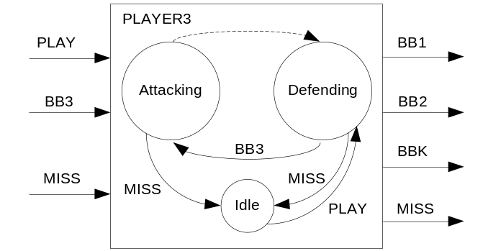
-Player3=<S, X, Y, δ_{int}, δ_{ext}, λ, ta>
S={playerState ε {Attacking, Defending, Idle}, sendBB2, sendBB1, sendBBK, sendMISS, random, thinking_time}
X={PLAY, BB3, MISS}
Y={BB2, BB1, BBK, MISS}
δ_{int}(Attacking)=Defending
δ_{int}(playerState){
//Internal transition occurs when user is done attacking.
if(playerState==Attacking) playerState=Defending;
passivate();
}
δ_{ext}(BB3, Defending)=Attacking
δ_{ext}(MISS, Attacking)=Idle
δ_{ext}(MISS, Defending)=Idle
δ_{ext}(PLAY, Idle)=Defending
δ_{ext}(S,e,X){
if(X.port==MISS){
// someone has missed the ball
playerState = Idle; ta(playerState) = infinity; //passivate
}
else if(X.port==PLAY){
// There are enough people to being playing
// Move to defending state and wait
playerState = Defending; ta(playerState) = infinity; //passivate
}
else if(X.port==BB3){
//Generate random number to see if ball is missed
playerState = Attacking; ta(playerState)=thinking_time;
random = generate random number
if(X.value < random){
sendMISS=true
playerState = Idle; ta(playerState) = infinity; //passivate
}
else{
// ball hit
//Generate random number to decide who to send ball to
random = generate random number
if(random<0.33){
sendBB2=true
}
else if(random<0.67){
sendBB1=true
}
else{
sendBBK=true
}
}
}
}
λ(Attacking)= sendBB2 || sendBB1 || sendBBK || sendMISS
λ(playerState){
if(sendBB2){
sendOutput(time, BB2, 1);
}
else if(sendBB1){
sendOutput(time, BB1, 3);
}
else if(sendBBK){
sendOutput(time, BBK, 3);
}
else{
sendOutput(time, MISS, 3);
}
}
ta(Attacking)=thinking_time1
ta(Defending)=INFINIT
ta(Idle)=INFINITY
TEST INPUT:
00:00:00:01 PLAY 1
00:00:00:10 BB3 2
00:00:00:30 BB3 7
00:00:00:31 MISS 1

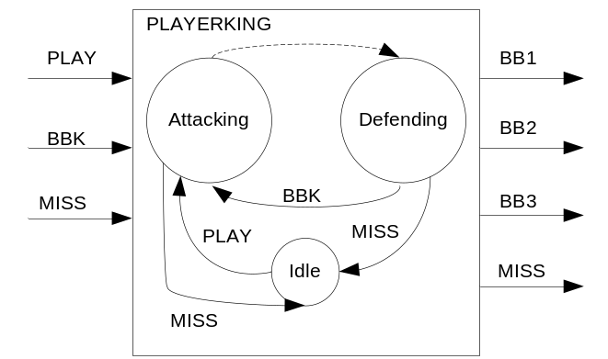
-PlayerKing=<S, X, Y, δ_{int}, δ_{ext}, λ, ta>
S={playerState ε {Attacking, Defending, Idle}, sendBB2, sendBB3, sendBB1, sendMISS, random, thinking_time}
X={PLAY, BBK, MISS}
Y={BB2, BB3, BB1, MISS}
δ_{int}(Attacking)=Defending
δ_{int}(playerState){
//Internal transition occurs when user is done attacking.
if(playerState==Attacking) playerState=Defending;
passivate();
}
δ_{ext}(BBK, Defending)=Attacking
δ_{ext}(MISS, Attacking)=Idle
δ_{ext}(MISS, Defending)=Idle
δ_{ext}(PLAY, Idle)=Attacking
δ_{ext}(S,e,X){
if(X.port==MISS){
// someone has missed the ball
playerState = Idle; ta(playerState) = infinity; //passivate
}
else if(X.port==PLAY){
// There are enough people to being playing
// Move to defending state and wait
playerState = Attacking; ta(playerState)=thinking_time;
//Generate random number to decide who to send ball to
random = generate random number
if(random<0.33){
sendBB2=true
}
else if(random<0.67){
sendBB3=true
}
else{
sendBB1=true
}
}
else if(X.port==BBK){
//Generate random number to see if ball is missed
playerState = Attacking; ta(playerState)=thinking_time;
random = generate random number
if(X.value < random){
sendMISS=true
playerState = Idle; ta(playerState) = infinity; //passivate
}
else{
// ball hit
//Generate random number to decide who to send ball to
random = generate random number
if(random<0.33){
sendBB2=true
}
else if(random<0.67){
sendBB3=true
}
else{
sendBB1=true
}
}
}
}
λ(Attacking)= sendBB2 || sendBB3 || sendBB1 || sendMISS
λ(playerState){
if(sendBB2){
sendOutput(time, BB2, 4);
}
else if(sendBB3){
sendOutput(time, BB3, 4);
}
else if(sendBB1){
sendOutput(time, BB1, 4);
}
else{
sendOutput(time, MISS, 4);
}
}
ta(Attacking)=thinking_time
ta(Defending)=INFINITY
ta(Idle)=INFINITY

TEST INPUT:
00:00:00:01 PLAY 1
00:00:00:10 BBK 2
00:00:00:30 BBK 7
00:00:00:31 MISS 1

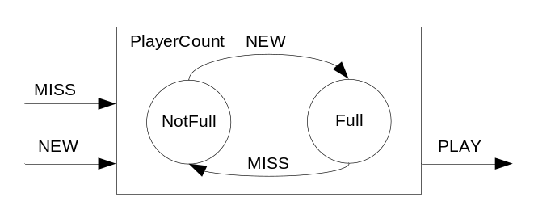
-PlayerCount==<S, X, Y, δ_{int}, δ_{ext}, λ, ta>
S={playerState ε {NotFull, Full}, count}
X={NEW, MISS}
Y={Play}
δ_{int}(s){ passivate();}
δ_{ext}(MISS, NotFull)=Full
δ_{ext}(NEW, Full)=NotFull
δ_{ext}(S, e, X){
if(playerState == full){
count--;
playerState=NotFull;
passivate();
}
else{
count++;
if(count == 4) playerState = Full;
passivate();
}
}
λ(Full)=Play
λ(playerState){
if(playerState==Full) output(time, PLAY, 5);
}
ta(NotFull)= INFINITY
ta(Full)=INFINITY

TEST INPUT: For the PlayerCount model, the test is to check that the play event is sent when there are 4 players in the game. Therefore send 4 new players to the game and check that the PLAY event is sent out. Then test having a player miss a ball and have to wait for a new player to join the game.

00:00:00:01 NEW 1
00:00:00:10 NEW 2
00:00:00:30 NEW 3
00:00:00:40 NEW 4
00:00:00:51 MISS 1
Part 3: Results and Variations from Original Specification

Each of the atomic models was built and tested separately. To run the simulation for each individual atomic model, you just need to run the MA file of the same name. Since all 4 players are similar, I am only showing the test results in the report for one of the four players. Here is the test run for Player1.

00:00:00:001 play 1.00000 – send to Player1’s input play port.
00:00:00:010 bb1 2.00000 – send to Player1’s input bb1 port, simulating Player1 getting ball
00:00:00:011 bbk 1.00000 – Player1 sends ball to Player King, through output port bbk
00:00:00:030 bb1 4.00000 – send to Player1’s input bb1 port
00:00:00:031 bbk 1.00000 - Player1 sends ball to Player King, through output port bbk
00:00:00:050 bb1 4.00000 – send to Player1’s input bb1 port
00:00:00:051 bb3 1.00000 - Player1 sends ball to Player3, through output port bb3
00:00:02:031 miss 1.00000 – send to Player1’s input miss port

In this test we are sending from the EV file the play and miss events. The Player then decides where to send the ball using random numbers.

The next test is of the PlayerCount atomic model. This model keeps track of the number of people currently in the game and notifies all the players when they can start playing.

00:00:00:001 new 1.00000 – send to new port – simulates a player arriving on the court
00:00:00:010 new 1.00000 – send to new port – simulates a player arriving on the court
00:00:00:030 new 1.00000 – send to new port – simulates a player arriving on the court
00:00:00:040 new 1.00000 – send to new port – simulates a player arriving on the court
00:00:00:041 play 5.00000 – sends out message that the game can begin
00:00:01:051 miss3 1.00000 – notifies the player count that player 3 missed the ball
00:00:03:000 new 1.00000 – send to new port – simulates a player arriving on the court
00:00:03:001 play 1.00000 – sends out message that the game can begin

Together the 4 players and the PlayerCount make up the coupled model KingsCourt. Once they were all tested and built, it came to test their interactions with one another. In this test we send 4 new events to the count, so that there are 4 players in the game then ensure the play event is sent out and the 4 players play.

00:00:00:001 new 1.00000 – send to new port – simulates a player arriving on the court
00:00:00:011 new 1.00000 – send to new port – simulates a player arriving on the court
00:00:00:021 new 1.00000 – send to new port – simulates a player arriving on the court
00:00:00:031 new 1.00000 – send to new port – simulates a player arriving on the court
00:00:00:032 play 5.00000 – sends out message that the game can begin
00:00:00:033 bb3 4.00000 – PlayerKing sends ball to Player3
00:00:00:034 bbk 3.00000 – Player3 sends ball to PlayerKing
00:00:00:035 bb3 4.00000 – PlayerKing sends ball to Player3
00:00:00:036 miss_out 3.00000 – Player3 misses the ball
00:00:04:031 new 1.00000 – New player arrives
00:00:04:032 play 1.00000 – New game has started
00:00:04:033 bb1 4.00000 – PlayerKing sends ball to Player1
00:00:04:034 bb2 1.00000 – Player1 sends ball to Player2

The next component is the line of players waiting to play the game. This is implemented as a very simple queue. The first four players who arrive are sent straight into the game. Everyone else must wait in line unless there is an empty space in the game.

00:00:00:001 in 1.00000 – new player arrives
00:00:00:002 new 1.00000 – send new player to game
00:00:00:011 in 1.00000 – new player arrives
00:00:00:012 new 1.00000 – send new player to game
00:00:00:023 in 1.00000 – new player arrives
00:00:00:024 new 1.00000 – send new player to game
00:00:00:054 in 1.00000 – new player arrives
00:00:00:055 new 1.00000 – send new player to game
00:00:01:001 in 1.00000 – new player arrives – has to wait in line
00:00:01:021 miss 1.00000 – player leaves game, send new player in
00:00:01:022 new 1.00000 – new player

Finally, the last test is to join the KingsCourt coupled model with the simple queue to have the whole system run. This can be seen by simulating the Top.MA. The in events are sent to the queue. If the game is not full, the players are sent to the game. Once the PlayerCount knows the game has 4 players it tells the players to start playing. Each time a player misses the ball, that player notifies all the other players it has missed the ball, as well as the PlayerCount and the queue. If there is someone waiting in line, they should be sent to the game right away. Otherwise, the players wait for a new player to join.

From the original specification to the final product a few things were changed. The first thing was the naming of the ports. I discovered that an input and output port could not be named the same, which slightly changed the Player models. The second thing that was changed was the queue, which was simplified. I realized upon implementing the code that I only need to know how many people were in line. So in this model the queue is a basic counter.

